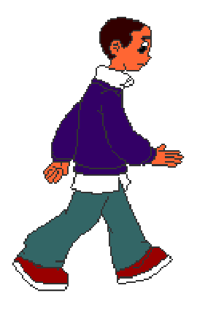


Apples falling from the sky
BPSO iCompute 3/31/17

- Start with three sprites: an apple, a poison apple, and Johnny Appleseed.
- Make Johnny move along the bottom of the screen with arrow keys. He should not go up and down, just side to side. He should not go off the edge of the screen. Remember how we did arrow key movement in the maze game? You will do something similar here.
- Make the apples fall from the sky. Here are some tips:
  - Apples should glide straight down. That means they will always move in a straight line along the x dimension, but the y will be changing.
  - When an apple gets to the bottom of the screen, it should disappear (hide) and then reappear at the top, but in a different (random) location.
  - The start and end y values will always be the same. The x value will change every time the apple starts over again at the top. Think about how you will use a variable to figure out what the x value should be each time.
- When Johnny catches an apple, he should get more points. When he catches a poison he should lose a life. “Catching” is more or less as the same as “getting hit by” in the dodging game from a couple weeks ago. Be careful to control how many points/lives are gained/lost when contact is made--this can get out of control easily!
- If Johnny catches 20 apples before losing 3 lives, the game is over and the player has one. Let them know! If he loses 3 lives before catching 20 apples, the game is over and the player loses. Let them know!

Got that far? Great. Now make it more challenging. Choose one or more of the following additional features:
1. More apples
2. Faster apples
3. Missing an apple causes lost points
4. Certain point levels allow you to get another life
5. Apples zig zag on their way down, randomly.
6. Golden apples are worth more
7. Player loses health instead of lives
8. Some apples do more damage (radioactive apples?)

Make it more engaging
1. Johnny points in the direction he is moving and animates to show that he is walking.
2. Poisoned/radioactive apples use animation to look creepier
3. Use animation to show when an apple is caught (yay) or a poison apple hits Johnny (boo)

